**Shape Printer**

Hi, PPTI 16 fellows. In purpose to practice on how you must think when creating a program in a computer using selection and repetition, this practice case will help you to translate from algorithm and procedures to source code in C programming language. Hope this helps!

When the program has been run, here’s the program flow that you need to create:

* In the beginning of program’s execution, several **menu options** will be **shown**. Each of menu will print different shape. Ask user to **input** **menu option number**.

**Figure 1 Main menu**

* If user inputs:
  + **Menu 1** (Rectangle), do:
    - **Ask** user to input:
      * **Rectangle width**, **validate** the input must be **more than 0**
      * **Rectangle height**, **validate** the input must be **more than 0**
    - Then, **print rectangle** based on given width and height

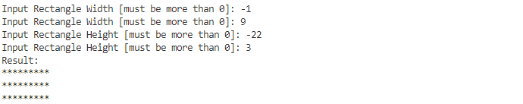

**Figure 2 Rectangle menu input(s) and result**

* + **Menu 2** (Right Triangle), do:
    - **Ask** user to input:
      * **Triangle size**, **validate** the input must be **more than 0**
    - Then, **print right triangle** based on given size

**Figure 3 Right triangle input(s) and result**

* + **Menu 3** (Equilateral Triangle), do:
    - **Ask** user to input:
      * **Triangle size**, **validate** the input must be **more than 0** and it must be an **odd number**
    - Then, **print equilateral triangle** based on given size

**Figure 4 Equilateral triangle input(s) and result**

* + **Menu 4** (Exit), do **print** “Thank you for using this app!” **message** and **close** the **application**.

**Figure 5 Input exit menu**

* + Otherwise, do **print** “You must input valid menu number!” **message**.

**Figure 6 Input invalid menu option number**

* The **application** will be **closed** only if user **picks menu 4** (Exit), otherwise the application will show **main menu** repeatedly.